LV Adapter: Getting Default Values At Edit Time
TestStand Version: 2010 SP1

Author: Jose A. Hernandez
Feature Spec: CAR 158183
Dependencies: All supported versions of LabVIEW

Test Category: [ Functional ]

Description
This test plan covers getting the default values of controls wired to a VI’s connector pane at edit time.

Preparation
Make VIs that have controls wired to their connector pane and make sure those controls have default values and some without. The controls should include types by themselves (not in a cluster or an array), arrays (n-dimensions, where n >= 1 && n <=3), clusters, and array of clusters. The types of the controls include the following:

Numbers: Numbers of type Int8, UInt8, Int16, UInt16, Int32, UInt32, float, double, extended, complex float, complex double, complex extended, real matrix, complex matrix. When using LV 8.6.1 and later, Int64 and UInt64.
Rings: Enums, Text, menu,
String: ASCII and Binary strings (this is only a TestStand setting), timestamps, paths, plots, multi-byte strings, DAQ Channel
References: ActiveX, .NET, IO (DAQmx Task Name, VISA resource name, etc.)
Waveforms: Analog of any numeric type including complex waveforms (LV 9.0.1 and later for complex), Digital, and Digital Data
Others: Booleans, LV classes (LV 9.01 and later), Tab

For arrays, make sure the default value for an array element is other than 0 or empty string. To do this for a numeric array, create a numeric control and set is default value to other than 0 and then insert the numeric control to the array. The default value for new elements will be other 0. Do this for array of strings and array of clusters.

Make sure some of the controls are set to be indicators and have default values. Make sure the indicators include an enum control.

Include some unsupported data types such as Fixed Point numbers, complex waveforms for LV version older than 8.6.1 and 64-bit numbers for versions older than 8.6.1. Make sure to include those controls in a cluster and an array.

Make some of the controls required in the VI connector pane.

Add all those VIs to a LV project so they can be called in a context of a project from TestStand.

You can start by using VIs located in //TestStand/WebPages/TestCases/Adapters/LabVIEW/Media/Controls With Default Values/<LV Version>/. Some of the VIs in the folder have a while loop with a stop button. Make sure you check the option “Show VI Front Panel When Called” to avoid getting what would appear as a hang when running in the LV Run-Time Engine and LV Dev. You will need to press the stop button to allow the VI to finish.

NOTE: There is problem with plots control with defaults values. The default value is causing LV to generate an invalid XML string which is used by TestStand to read the prototype of the VI. These problems have been reported in LV CAR 288757.

Validation
Sequence Editor

Configure the LV adapter to use the RTE you are testing.

On a new sequence, insert LV steps and call each VI you created above.
Verify that the default values for the controls are shown for all parameters set to use their default value.
Verify that no default values appear for output parameters.
Verify output enums don’t have a combo box.
Verify that you don’t get any errors when using VIs that have unsupported data types. The default values should be blanks. There might be some exceptions, but most cases should be blank.
For arrays, verify that expanding them create the default array elements and that the default values for the elements match the values in the VI. Add and remove array elements and verify that the default values still match the values in the VI.
For output arrays, verify that the default array elements are created, but they have no default values.

Run the sequence and verify that all cluster and array elements using their default values are correct.

When using LV 9.0.1 and later, repeat the same process, but with VIs called in a context of a project.

Configure the LV adapter to use the LV Development system and repeat the same steps.

Configure the LV adapter to Auto Detect and try adding and removing array elements. Reload prototype of some VIs and verify that the default value does not change.

Test Impact for CAR 299071

Do the following steps when using LV 2011 and later:
- Insert a new LV step in a sequence file
- In the LV step, specify the VI WebPages\TestCases\Adapters\LabVIEW\Media\Controls With Default Values\10.0.1\Enums.vi
- Expand all the parameters and verify that all enum parameters have a combo box in the value column.
- For the parameter “Array”, insert a couple more element to make the total number of elements be 7
- For the parameter “Array Of Clusters”, insert two new elements to make the total be 3
- Expand each cluster array element and add three array elements to its “Array” cluster element. The “Array Of Clusters” parameter should look like the picture below.
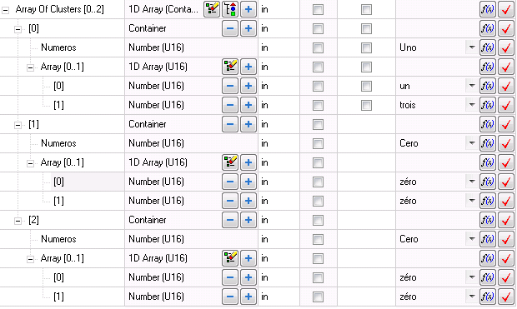
- Verify that all enum parameters have a combo box in the value column.
- Save the sequence file and close it.
- Reopen the sequence file and select the step you created in step 1
- Expand all the parameters and verify that all the enum parameters have combo boxes in the value column

Test Impact for CAR 256438 (TestStand 2012 and later)

- Insert a new LV step in a sequence file
- In the LV step, specify the VI WebPages\TestCases\Adapters\LabVIEW\Media\Controls With Default Values\10.0.1\Strings.vi
- Verify that the Type column for parameter Array does not have any buttons
- Uncheck the checkbox under the Default column for parameter Array
- Verify that the buttons Delete All Array Items and Add Array Item appear as seen below
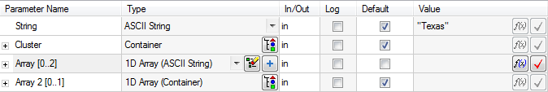
- If using LV 2012, do the following
  - Specify an argument for Array. It can be anything.
  - Expand the array and verify the argument is not deleted
  - Collapse Array
  - Delete the argument
- Click on the Delete All Array Items button
- Verify that the parameter name now shows Array [0..empty]
- Verify that expand button also disappears for parameter Array
- Click on the Add Array Item button and verify only one item is added
- Click the checkbox under the Default column for parameter Array
- Verify that the parameter is collapsed and the name is now Array [0..2]
- Expand Array and click Yes on the dialog that appears
- Verify that three array elements are added
- Click the checkbox under the Default column for parameter Array
- Verify that the parameter is collapsed and the name is now Array [0..2]
- Uncheck the checkbox under the Default column for parameter Array
- Click on the Add Array Item button
- Verify that the array expands and it has four elements
- Click on the Delete All Array Items button
- Verify that the parameter name now shows Array [0..empty]
- Verify that expand button also disappears for parameter Array
- Now, specify the VI WebPages\TestCases\Adapters\LabVIEW\Media\Controls With Default Values\10.0.1\Array Of Numbers.vi as the module of the step
- Repeat steps 3 to 22 with any of the numeric array parameters
- Now, specify the VI WebPages\TestCases\Adapters\LabVIEW\Media\Controls With Default Values\10.0.1\ComplexNumbers.vi
- Expand the parameter Array 2D and click Yes on the dialog that appears
- Verify that you don’t get any errors.
- Verify that the names for the Real and Imaginary arrays under parameter Array 2D do not show array indices.
- Click the checkbox under the Default column for parameter Array 2D
- Verify that the array is collapsed and the indices for Array 2D show the default size
- Expand Array 2D one more time and click on the Delete Array Elements button
- Verify the array elements are deleted and the indices for Array 2D are now [0..empty][0..empty]
- Click the checkbox under the Default column for parameter Array 2D
- Verify that the array is collapsed and the indices for Array 2D show the default size

Test Impact for CAR 296671 (TestStand 2012 and later)

- Insert a new LV step in a sequence file
- Specify the VI WebPages\TestCases\Adapters\LabVIEW\Media\Controls With Default Values\10.0.1\Array Of Numbers.vi
- Verify that all the array parameters (except for Array 15) have the expand button and the array bounds in the Parameter Name column don’t specify empty arrays.
- Click on the Edit VI button.
- Modify all the control to be indicators
  - Right click on each control and select Change to Indicator
- Without saving the VI, go back to the Sequence Editor and reload the prototype of the VI by clicking on the Reload VI Prototype button
- Verify that all the arrays have the indices set to [0..empty]
- Expand the three arrays of complex numbers (Array 11, Array 12, and Array 10) and verify that no array elements are inserted.

Test Impact for CAR 335150 (TestStand 2012 and later)

- Insert a new LV step in a sequence file
- Specify the VI WebPages\TestCases\Adapters\LabVIEW\Media\Controls With Default Values\10.0.1\Cluster And Array Of Numbers.vi
- Select the parameter named Cluster (the first parameter)
- Press the numeric key ‘*’
- In the dialogs that come up, click on the No button
- Verify that no errors are generated and the cluster expands. It should look similar to the screenshot below.
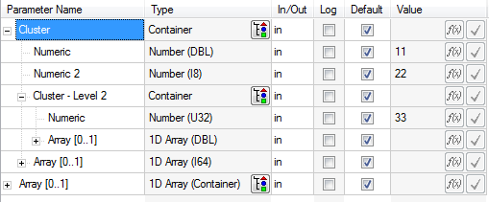
- Make a copy of Cluster And Array Of Numbers.vi and name it Cluster And Array Of Numbers2.vi
- Insert a new LV step and specify Cluster And Array Of Numbers2.vi as its module
- Click on the Edit VI… button and modify the name of the control “Cluster – Level 2” to “Cluster Level 3” and save the VI
- Reload the prototype
- Select both steps and make sure the Cluster parameter is using its default value
- Select the Cluster parameter and press the numeric key ‘*’
- Verify you get the dialog below
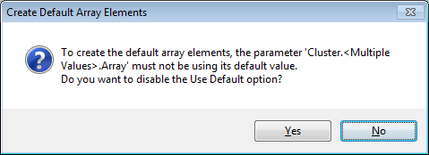
- Click No in all the dialogs
- Verify no errors are generated and the cluster expands. It should look similar to the screenshot below
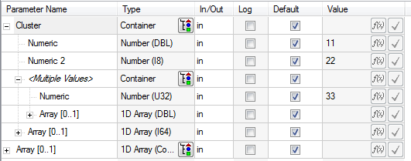

Test Impact for CAR 344948 (TestStand 2012 and later)

Do the following steps when using LV 2012 and later:
- Insert a new LV step to a sequence
- Specify the module of the LV step to be //TestStand/WebPages/TestCases/Adapters/LabVIEW/Media/Controls With Default Values/12.0/MultiDimensionalArrays.vi
- Expand all the array parameters of the VI and verify no errors are generated and the default values are shown for the array elements
- Click on the Edit VI… button
- In the VI, right click on the third column of the control Numeric Array and select Data Operations->Delete Column to make the array a 2x3 array
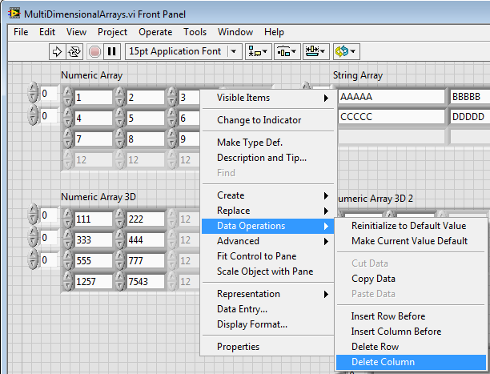
- Select Edit->Make Current Values Default to make the new array size the default value and save the VI (will have to make the VI writeable)
- Go back to the Sequence Editor and select the Properties tab in the Step Settings pane
- Select the Module tab and verify you don’t get any errors
- Run the LV step and verify it runs without any errors.
- Check the checkbox under the Default column for the parameter Numeric Array
- Expand the array again and click Yes on the dialog that appears
- Verify you don’t get any errors and the array is now a 2x3 array and the default values are shown
- Run the LV step and verify it runs without any errors.

Test Impact for CAR 384407 (TestStand 2012 SP1 and later)

Do the following steps when using LV 2012 and later:
- Create a VI that has three inputs, one with an array of waveforms, one with an array of digital waveforms and the last one with an array of digital data. Add some elements to the arrays and then make them as the default data.
- Configure the LabVIEW adapter to use the LabVIEW development environment.
- Insert an action step and configure it to use the VI previously created.
- For the three inputs click on the default, expands the arrays and you should see your default data.
- Configure the LabVIEW adapter to use the appropriately LabVIEW Run-time and redo steps 3 an 4.

Test Impact for CAR 382692 (MultiByte OS with TestStand 2012 SP1 and later)

Do the following steps when using LV 2012 and later:
- Make sure TestStand is configured to use LV RTE.
- Synch to files //TestStand/WebPages/TestCases/Adapters/LabVIEW/Media/CARs/ and open the sequence CAR 382692.seq.
- Select “String Value Test” Step, Step Settings→Properties→Additional Results
- Close the sequence and open it again.
- Select the “String Value Test” Step. ( Do not go to Module Tab)
- Verify that the “Value to Log” in the Additional Results is not empty.
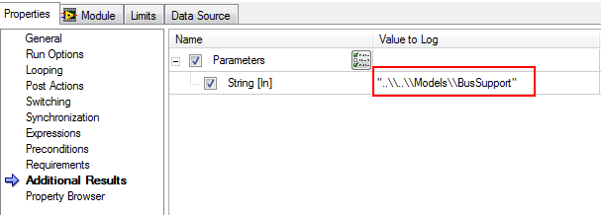

Note: Do not file CAR if the “Value to Log” is empty. There is already a CAR filed for this Issue. Refer CAR 409805. Please update this section when the CAR mentioned is closed.
- Set a breakpoint in the end group of Main.
- Run the file using entry point Single Pass.
- Notice that the Additional Results are present in the ResultList.
- Go to StepSettings→Properties→Additional Results and verify that Value to Log is not empty.
- Resume the execution and verify that the value is correctly logged in the report.

Test Impact for CAR 381684 (TestStand 2012 SP1 and later)

Do the following steps wen using LV 2012 and later:
- Synch to files //TestStand/WebPages/TestCases/Adapters/LabVIEW/Media/CARs/
- Open the sequence CAR 381684.seq.
- Run the file using entry point Single Pass.
- Verify in report that the Additional Results shows Byte Array ("E@=3@JG0100h_LCC_;AC_;a=G?9=9Y>a0Z]>0^]X`8_Z110IAG8H").
- Select step String Value Test, go to Step Settings and change the parameter type to ASCII String.
- Run the file using entry point Single Pass.
- Verify in report that the Additional Results shows ASCII string
( ..\..\Models\BusSupport)
- Repeat the above steps using both LV RTE and LV Dev.

Any UI

Pick any UI and repeat the same steps from the Sequence Editor section. This time you will be testing the LV Specify Module dialog instead of the LV panel.

LV UI running in LV

Repeat the same steps from the Sequence Editor section.

With the LV adapter set to use the RTE matching the LV version the UI is running on, try loading 7.1.1 VIs and verify that you don’t get any errors loading those VIs, getting their default values, and running them.

With the LV adapter set to use LV Development system, try loading 7.1.1 VIs and verify that you also don’t get any errors loading the VIs, getting their default values, and running them.
Select Edit Code on the LV steps and verify you don’t get any errors.

National Instruments Confidential
Copyright © 2005 National Instruments Corporation

